Initial Plugin Download

1. Download OrgMeasure_.ijm
2. Drag OrgMeasure_.ijm into Plugin folder of ImageJ
3. Plugin will now be available under Plugins tab at very bottom named ‘OrgMeasure’
4. Set Measuring Settings: Analyze -> Set Measurements...
5. 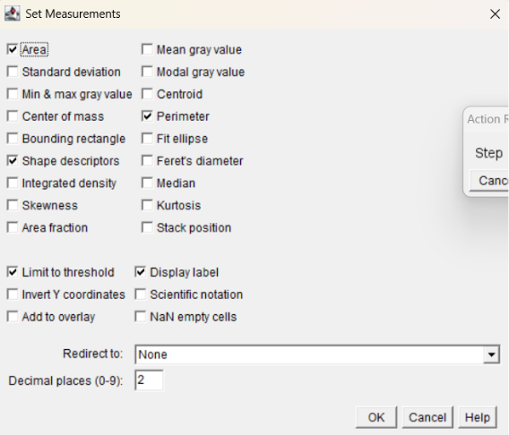

Plugin Use and Analysis

1. Open invasion assay folder at desired timepoint with desired .tifs
   1. Save ‘Huang Lab-Invasion' on OneDrive as a shortcut
   2. Go to OneDrive- University of Texas Southwestern ->Huang Lab-Invasion-> Experiment Folder -> Timepoint Sub-Folder
2. User Log “ Step 1: Please clear the background manually if needed, then click OK to continue.”
   1. Select Freehand tool, outline area around organoid
   2. Edit -> Clear Outside
   3. Click OK for the next step
3. User Log: “Adjust threshold manually, then click OK to continue.”
   1. Drag the upper bar until the area is as completely covered with red as possible.
4. User Log: “Smooth additionally as needed and clear the background outliers manually, then click OK to continue.”
   1. Click Ctrl+Shift+S to repeatedly smooth (can hold down to apply repeatedly). Adjust threshold until a rough area of starting organoid is selected.
      1. If still too many holes Process -> Binary -> Fill Holes
5. User Log: “Adjust threshold manually, then click OK to continue.”
6. Once OK is pressed the image file automatically saves in Subfolder ‘ProccessedBinary’. Go to Results table to copy measurements.
7. Repeat until all .tif files analyzed.